CRISP

for

Cloud Computing (INFS 803)

by

GROUP 8

Juan Herbst (13840146)

Mike Chene (19070279)

Tommaso Cammelli (23215488)

Auckland University of Technology, Auckland, New Zealand

Table of Contents

Introduction 3

Project Planning 3

Project Design 3

User Experience (UX) 3

Database Schema Design 6

Solution Architecture 6

Work Log 6

Cloud Implementation 6

User Manual 6

RESTful API 6

Summary 6

Table of Figures

**Figure 1** Recruiter Create, Update or Retrieve their Profile. 3

**Figure 2** Recruiter Creates a Job Posting. 3

**Figure 3** Candidates Create, Update or Retrieve their Profile. 4

**Figure 4** Candidate Apply for a Job 5

**Figure 5** Recruiter Finds and Engages with Candidates 5

## Introduction

## Project Planning

## Project Design

### User Experience (UX)

**Figure 1**Recruiter Create, Update or Retrieve their Profile.

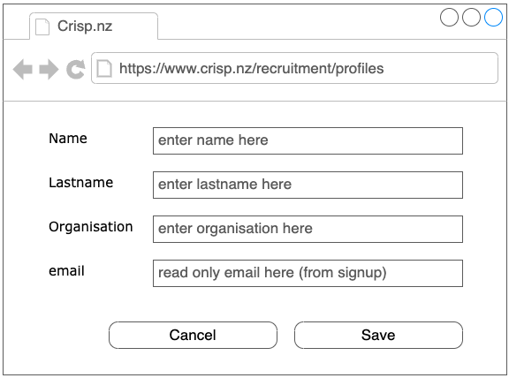

The recruiter initiates navigation to the profile screen, where they are presented with the functionality to undertake actions such as creation, updating, or retrieval. It is crucial to note that the email address associated with the recruiter's profile is fetched from the authentication and authorisation service. Consequently, the email address is immutable and cannot be modified, as it is a pivotal identifier utilised during the signup process.

**Figure 2**   
Recruiter Creates a Job Posting.

In recruitment activities, recruiters navigate to the job posting screen, where they encounter the functionality to perform various actions, including creating, updating, or retrieving job postings. It is pertinent to acknowledge that the category associated with each job posting is selected from a predetermined drop-down list, pre-populated with available options. This mechanism ensures consistency and accuracy in categorising job postings, streamlining the process for recruiters.

**Figure 3**   
Candidates Create, Update or Retrieve their Profile.

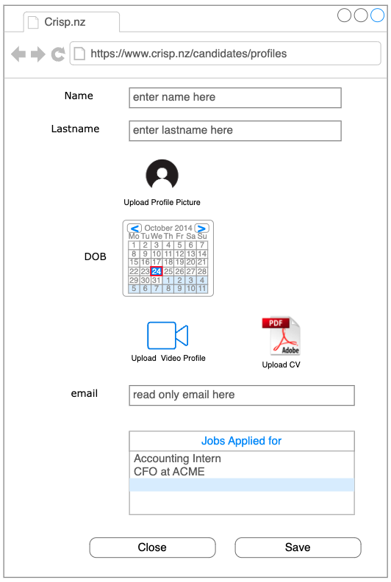

In the recruitment process, a candidate accesses the profile screen, where they are presented with the functionality to perform actions such as creating a profile, updating, or retrieving an existing profile. It is imperative to emphasise that the candidate's email address is fetched from the authentication and authorisation service. Consequently, the email address remains immutable and cannot be modified, as it is a foundational identifier utilised during the signup process.

**Figure 4**   
Candidate Apply for a Job

The candidate initiates navigation to the available jobs page, where they are prompted to select a category of interest. Upon selecting a specific category, the system retrieves and displays a list of jobs corresponding to the chosen category. To view the details of a particular job, the candidate double-clicks on the respective job listing, thereby accessing comprehensive job information. Within the job detail view, the candidate is presented with the option to apply for the job with a single click, streamlining the application process and enhancing user convenience.

**Figure 5**   
Recruiter Finds and Engages with Candidates

To facilitate interaction with candidates who have applied for advertised roles, the recruiter navigates to the jobs page. Here, the recruiter selects the desired category, followed by a double-click action on the list of jobs corresponding to the specified category. Subsequently, a list of candidates associated with the selected job listings emerges. Upon double-clicking on a candidate's name, a detailed screen surfaces, presenting the recruiter with comprehensive information including the candidate's contact details, curriculum vitae (CV), and a video profile where applicable. Moreover, the recruiter is afforded the option to annotate pertinent observations or remarks against the candidate, facilitating efficient management of candidate evaluations and feedback.

## Database Schema Design

## Solution Architecture

## Work Log

## Cloud Implementation

## User Manual

## RESTful API

## Summary